**Number Systems Used In Computers**

Complete the following table:

|  |  |  |  |
| --- | --- | --- | --- |
| **Number System** | **Number Base** | **Digits Used** | **Purpose** |
| Decimal | Base 10 | 0 to 9 | Used for communicating with human users |
| Binary |  |  |  |
| Octal |  |  |  |
| Hexadecimal |  |  |  |

**Decimal vs. Binary System**

Write down the definition of a **Bit** in computer terminology:

Complete the following table:

|  |  |  |
| --- | --- | --- |
|  | **Decimal System** | **Binary System** |
| Uses Digits |  |  |
| Addition Examples |  |  |
| Powers of 10 |  |  |
| Evaluate 111 |  |  |

**Powers of 2**

|  |  |  |  |  |
| --- | --- | --- | --- | --- |
| **Power  of 2** | **Decimal Value** | **Integer Range** | **Number  of Bits** | **Computer Binary** |
| 21 | 2 | 0 - 1 | 1 | 0001 |
| 22 | 4 | 0 - 3 | 2 | 0011 |
| 23 |  |  |  | 0111 |
| 24 |  |  |  | 1111 |
| 25 |  |  |  | 0001 1111 |
| 26 |  |  |  | 0011 1111 |
| 27 |  |  |  | 0111 1111 |
| 28 | 256 | 0 - 255 | 8 | 1111 1111 |
| 29 |  |  |  | 0001 1111 1111 |
| 210 |  |  |  | 0011 1111 1111 |
| 211 |  |  |  | 0111 1111 1111 |
| 212 |  |  |  | 1111 1111 1111 |
| 213 |  |  |  | 0001 1111 1111 1111 |
| 214 |  |  |  | 0011 1111 1111 1111 |
| 215 |  |  |  | 0111 1111 1111 1111 |
| 216 | 65,535 | 0 – 65,534 | 16 | 1111 1111 1111 1111 |

**Conversions**

Convert the following binary numbers to decimal:

11 binary =

101 binary =

1010 binary =

Convert the following decimal numbers to binary:

6 decimal =

13 decimal =

**Binary Addition**

Add the following binary numbers. (verify your answers using decimal)

|  |  |  |  |  |  |  |  |  |  |  |  |  |  |
| --- | --- | --- | --- | --- | --- | --- | --- | --- | --- | --- | --- | --- | --- |
| |  |  | | --- | --- | | **0101** | **(decimal 5)** | | **+ 0010** | **(decimal 2)** | |  |  | | |  |  | | --- | --- | | **0101** | **(decimal 5)** | | **+ 1010** | **(decimal 10)** | |  |  | |
| |  |  | | --- | --- | | **0011** | **(decimal 3)** | | **+ 0010** | **(decimal 2)** | |  |  | | |  |  | | --- | --- | | **0110** | **(decimal 6)** | | **+ 0011** | **(decimal 3)** | |  |  | |

**Prefixes**

* Kilo (K) means __________________ Multiply by x______________
* Mega (M) means _________________ Multiply by x______________

* Giga (G) means __________________ Multiply by x______________
* Tera (T) means __________________ Multiply by x______________

**Examples**

1. 64 Kbps (Kilo-bits per seconds) = ___________________ bps (bits per second)
2. 256 Giga-bytes = _________________________________ bytes
3. 256 Giga-bytes = _________________________________ bits

**Computer Memory Structures**

|  |  |  |  |
| --- | --- | --- | --- |
| **Structure** | **Number of Bits** | **Largest Value** | **Used For...** |
| Bit |  |  |  |
| Byte |  |  |  |
| Word |  |  |  |
| Short Integer |  |  |  |
| Double Word |  |  |  |
| Long Integer |  |  |  |
| Memory Address |  |  |  |

**Memory Organization**

Bit (Binary Digit)

* One bit can have a value of ________ or _________
* Or a Boolean logic value of ________ or _________

|  |  |  |  |  |  |  |  |  |  |  |  |  |  |  |  |  |  |  |  |
| --- | --- | --- | --- | --- | --- | --- | --- | --- | --- | --- | --- | --- | --- | --- | --- | --- | --- | --- | --- |
| |  |  |  |  | | --- | --- | --- | --- | | 0 | 0 | 0 | 0 | | |  |  |  |  | | --- | --- | --- | --- | | 0 | 0 | 0 | 0 | | |  |  |  |  | | --- | --- | --- | --- | | 0 | 0 | 0 | 0 | | |  |  |  |  | | --- | --- | --- | --- | | 0 | 0 | 0 | 0 | |

Byte (8 bits)

* One byte has a size of ________ bits
* A byte has an unsigned integer value range from 0 to _________

|  |  |  |  |  |  |  |  |  |  |  |  |  |  |  |  |  |  |  |  |
| --- | --- | --- | --- | --- | --- | --- | --- | --- | --- | --- | --- | --- | --- | --- | --- | --- | --- | --- | --- |
| |  |  |  |  | | --- | --- | --- | --- | | 0 | 0 | 0 | 0 | | |  |  |  |  | | --- | --- | --- | --- | | 0 | 0 | 0 | 0 | | |  |  |  |  | | --- | --- | --- | --- | | 0 | 0 | 0 | 0 | | |  |  |  |  | | --- | --- | --- | --- | | 0 | 0 | 0 | 0 | |

Word (2 bytes or 16 bits)

* One word has a size of ________ bits
* One word has a size of ________ bytes
* A byte has an unsigned integer value range from 0 to _________

|  |  |  |  |  |  |  |  |  |  |  |  |  |  |  |  |  |  |  |  |
| --- | --- | --- | --- | --- | --- | --- | --- | --- | --- | --- | --- | --- | --- | --- | --- | --- | --- | --- | --- |
| |  |  |  |  | | --- | --- | --- | --- | | 0 | 0 | 0 | 0 | | |  |  |  |  | | --- | --- | --- | --- | | 0 | 0 | 0 | 0 | | |  |  |  |  | | --- | --- | --- | --- | | 0 | 0 | 0 | 0 | | |  |  |  |  | | --- | --- | --- | --- | | 0 | 0 | 0 | 0 | |
|  | |  | |

Long or Double Word (4 bytes or 32 bits)

* One Long word has a size of ________ words
* A Long word has an unsigned integer value range from 0 to _________

|  |  |  |  |  |  |  |  |  |  |  |  |  |  |  |  |  |  |  |  |
| --- | --- | --- | --- | --- | --- | --- | --- | --- | --- | --- | --- | --- | --- | --- | --- | --- | --- | --- | --- |
| |  |  |  |  | | --- | --- | --- | --- | | 0 | 0 | 0 | 0 | | |  |  |  |  | | --- | --- | --- | --- | | 0 | 0 | 0 | 0 | | |  |  |  |  | | --- | --- | --- | --- | | 0 | 0 | 0 | 0 | | |  |  |  |  | | --- | --- | --- | --- | | 0 | 0 | 0 | 0 | |
|  | |  | |
| |  |  |  |  | | --- | --- | --- | --- | | 0 | 0 | 0 | 0 | | |  |  |  |  | | --- | --- | --- | --- | | 0 | 0 | 0 | 0 | | |  |  |  |  | | --- | --- | --- | --- | | 0 | 0 | 0 | 0 | | |  |  |  |  | | --- | --- | --- | --- | | 0 | 0 | 0 | 0 | |
|  | |  | |

**Questions**

1. What is the smallest memory object that can represent a character of information?
   1. Think… How many upper case letters in the alphabet (A to Z)?
      1. 26 capital letters
   2. Think… How many lower case letters in the alphabet (a to z)?
      1. 26 lower case letter
   3. Think… How many number digits (0 to 9)?
      1. 10 number digit
   4. Think… How many punctuation marks?
      1. There are 14 punctuation marks
   5. Add them all up
      1. 130
2. Research the ASCII characters set. What is it and how is it related to computer memory?
   1. It is a way that the computers communicate. ASCII is translated in binary and each character takes up to 1 byte of memory. Since each character is designated a number computers turn it into binary and transfers that info to other computers.
3. How are strings of characters (Google “String”) represented in computer memory?
   1. They are represented as strings of seven bits in ASCII.
4. How are negative integers represented in computer memory? (Include a diagram)
   1. They use a technique where the left most sign represents a negative number where 0 is positive and 1 is negative.  
      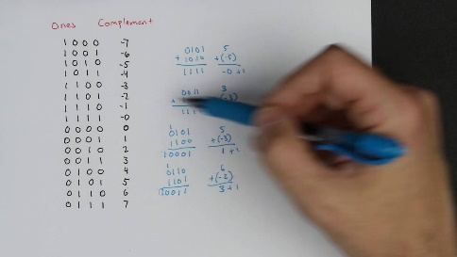
5. How are decimal numbers (Google “Floating Point”) represented in computer memory? (Include a diagram)
   1. They represent the numbers in scientific notations where it is then turned into binary but because they were written as scientific notations the binary numbers would be really long.  
      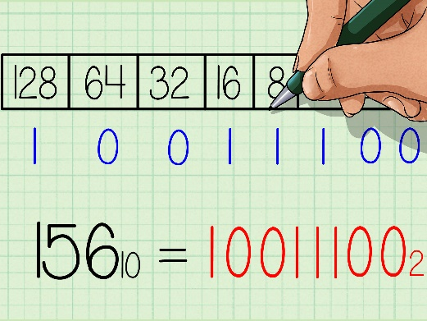
6. A Pixel is computer memory structure used to store image information. How is a Pixel represented in memory? (Include a diagram).
   1. Each pixel of color has a special code of binary to turn it into a specific color and with each bit of binary code it doubles the pixels that turn that color such as 1 bit = 2 pixel 2 bits = 4 pixels and 3 bits = 8 pixels. For RGB each color pixel is represented as 3 8Bit Channels that determines how much of R(red) or G(green) or B(blue).

